Print machines now-a-days are essentially a printhead running left and right on a moving piece of paper. We asked ourselves, why not get rid of the entire device, just put the printhead on a set of small wheels and let it run across a piece of paper. By doing so, we allow the printer to really be as little as possible.

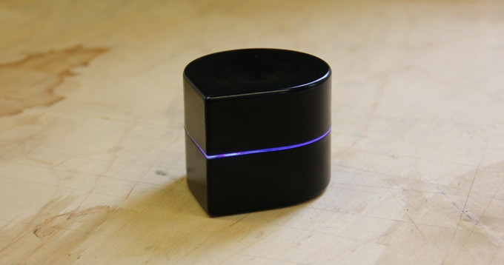

Our printer is entirely fitted for our day to day life. It has a rechargeable battery with an on\off switch, it connects directly to smartphones and to PCs, and it allows the user to print on any size piece of paper.

Physical dimensions and weight: 10 centimeters high and 11.5 centimeters in diameter and will weigh about 300g.

Materials: cover made from Polycarbonate

Media sizes: any standard size.

Print Speed: 1.2 ppm (estimated according to the prototype specs).

Print Quality: currently the prototype can reach up to 96x192 dpi, the final product will have higher resolution.

Ink Cartridge Configuration: one black cartridge.

Connectivity Technology: Wireless.

Interface: Bluetooth, Bluetooth BPP.

Connections: 1 x Micro Usb.  
  
Battery  
Type: Lithium Polymer.  
Run Time (Up to): 1 hour.  
Charge Time: 3 hours.  
  
Supported Os:  
Android, IOS, Linux, OSX, Windows.

